
22R to OM617 Power Steering Tensioner Addition Instructions
For high-res photos, download the instructions off www.doomsdaydiesel.net
The 22R power steering pump can be ran by itself and have the belt tensioned by the Mercedes dual-pulley alternator. However, to gain more adjustability and get more tension on the power steering pump pulley, the stock tensioner can be modified and added to the system. Shown in the pictures below is a Trail-Gear high-flow power steering pump and bracket. To make the stock Toyota tensioner work, you must cut off the top stud on the TG bracket.
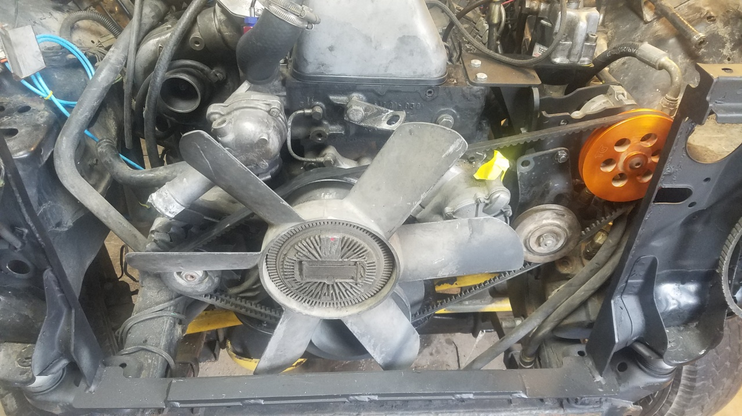
The supplied 3/8” formed bracket will bolt to the bottom to stabilize the tensioner. The other end bolts thru an old A/C compressor mounting hole on the engine. Be sure to Loctite the threads on all fasteners, as they undergo a lot of vibration. You may find it necessary to place a small weld from the tensioner plate to the P/S bracket. The weld would best be placed around the corner by the stud, and can easily be removed later if need be. You will now be able to tension the alternator first, and the Toyota tensioner second, to give your power steering pump ample belt tension.
